**YOUTHCAN! TRAINING MATERIAL**

YOUTH needs assessment workshop

how-to guide

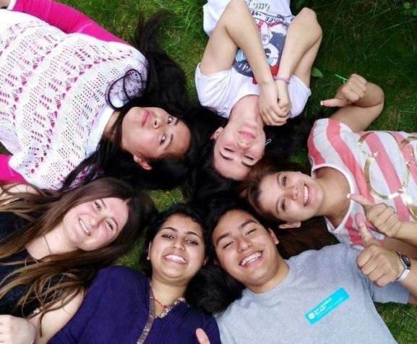

**TABLE OF CONTENT**

1 ABOUT THIS GUIDE 3

2 TIMELINE 3

3 PREPARATION OF NEEDS ASSESSMENT WORKSHOP 4

3.1 Organisational issues 4

3.2 Selection of participants 4

3.3 Clarify how the results will be used 4

4 HOW TO RUN THE CONSULTING SESSION ON EMPLOYABILITY 5

4.1 Materials needed for the session 8

5 ANNEXES 9

Available material 9

Annex 1: Game ideas 9

Annex 2: List of employability skills 1

Annex 3: Summary of workshop results (input to kick-off meeting) 1

Annex 4: Photographic/media consent form 2

# ABOUT THIS GUIDE

This is a practical guide about how to consult with young people aged 15-25years on the topic of employability in the frame of the YouthCan! project and corresponds to step 2 as shown below.

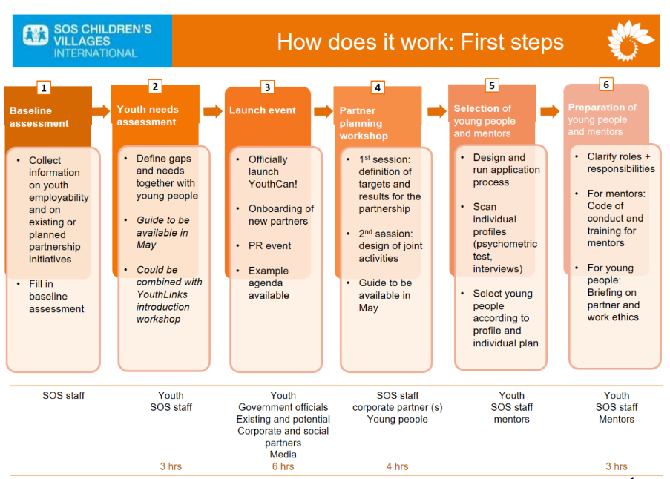

The aim is to offer support in the process of identifying the needs of young people, but the proposed methods can and should be adapted to the local context. This guide is written for national YouthCan! coordinators.

The aim of the needs assessment workshop is to collect detailed information on:

* What do young people need to be better equipped for their career (step 1)?
* What is the final goal in regard to youth employability (step 2)?
* What needs to be improved/changes as a precondition in order to get to this final goal (step 3)?

Workshops are expected to be run in all YouthCan! MAs.

# TIMELINE

This needs assessment should take place before starting YouthCan! activities. Ideally, it should even be done before the partner kick-off workshop ([link to guiding document](https://collaboration.sos-kd.org/Workspaces/WS_000169/Shared%20Documents/Trainings/Partner%20kick-off/YouthCan_partner%20workshop.docx?Web=1)) or in parallel.

# PREPARATION OF NEEDS ASSESSMENT WORKSHOP

## Organisational issues

* Translate (if necessary) material in national language
* Decide on the number of participants  
  Depends on the size of the MA. This workshop will take place either on programme or national level. The group size can vary from about 10 to 20 participants.
* Define time and venue of workshop
* Please try to work with young people living near the workshop venue and to use synergies with other YouthCan! events (e.g. YC! launch or partner kick-off) to save travel and accommodation cost. We recommend to calculate approx. 3 hours for the needs assessment workshop.
* Decide who will take on the facilitation role  
  We recommend the national YouthCan! coordinator to facilitate the workshop.
* Select young people and inform them about the project. Once they have given consent to their participation, make sure they are properly invited and informed in advance about the time, venue, and content of the workshop, and they are supported in organizing their participation.

## Selection of participants

* Target group depends on the scope of the YouthCan! project in the country. Select a mixed group of young people from alternative care, family strengthening programmes and possibly also from the community or other NGOs – aged between 15-25 years. Please try to keep a gender balance and a balance between different education levels and youth living in the rural/urban area.
* Bear in mind to not always include the most articulated and active young people, but bring in diverse young people.
* Participation has to be voluntary.

## Clarify how the results will be used

* **YouthCan!**  
  Results will mainly be used to plan concrete YouthCan! activities with corporate partner(s) to make sure that the YouthCan! programme responds to the young people’s needs. The results of the needs assessment should be brought in by the participating young people themselves to the YouthCan! planning workshop (kick-off meeting), which will take place shortly after the needs assessment workshop or in parallel.
* **National/local youth work**  
  In addition, please think about and define how you are going to communicate the results to the PD team or use it as an input to planning for actions related to youth employment in general.

## HOW TO RUN THE CONSULTING SESSION ON EMPLOYABILITY

|  |  |
| --- | --- |
| **Agenda proposal and explanation** | |
| **Activity** | **Description** |
| Preparation – before the workshop | * Arrange the room (a youth friendly set up, not formal; young people sitting in a circle and feeling comfortable) * Prepare flipcharts * Go through agenda a last time |
| Welcome  approx. 25 min.) | **Welcome**   * Moderator(s) welcome young people and introduce them self(ves) * Mix young people in pairs (randomly), make sure that they are with somebody they don’t know very well. In pairs, they start introducing each other. The game is to find six interesting things about the other person (e.g. food, hobby etc.). Say to participants that they have to be creative and respect the other person, but it would be good to discover as much from the other person as possible. * Afterwards, each of the pair starts to introduce each other in the plenary, meaning not themselves but the other person. * If it is a bigger group (more than eight people) ask the participants to introduce only one funny or particularly interesting thing they have learned about their partner.   **Group Exercise** At this moment it is helpful to do an exercise to build positive group dynamics. Time required: 10 min |
| Introduction of the session and agenda  approx.5 min.) | **Introduce objective of the session**   * **Core *message*** *The goal of the session is to establish the needs and challenges young people face with regards to employability.* * **Objective *of the day*** * To establish the needs and challenges of the young people aged 15-25 from across the SOS CV Member Association * To establish what young people propose as possible solutions to their needs and challenges * To create an understanding about what YouthCan! is and how it could works * **Why *we are doing this workshop***YouthCan! aims to create a network of partners, working together to improve the employability of young people and assisting young people to secure decent employment or self-employment. To best assist young people it is critically important to understand the needs, challenges and environment of the young people. Young people must be part of formulating the potential solutions to their challenges together with the partners to ensure a clear understanding the responsibilities of each partner and how YouthCan! will work.   Introduce the agenda of the day. |
| Rules  approx.5 min.) | Present the rules of the focus group (prepare them in a flip paper before the meeting and show it to participants)   * Turn off mobiles * Respect each other turns and speak one at a time * Respect different opinions * Hearing from everyone * Have fun   N**ote**: add more rules according to your own country – invite all the participants to add |
| Photograpic/ mediaconsent forms (if needed) | **Address the consent form for all the young people:**Prepare copies of the consent form for each participant, have them printed and ask them to sign. |
| Introduction to YouthCan!  approx.5 min.) | Explain YouthCan! You can use/adapt this presentation (please see annex). |
| **Step 1: Identify needs**  approx. 40 min. | Guiding question of this session:  **What would you need in order to be better equipped for your career?**   * Employability skills (see list below) * Other support factors (e.g. social support network)  1. Present the following employability skills, explain and clarify open questions (prepare a flipchart before the meeting including the following skills, but also leaving enough space for additional factors, app. 15 min.):   **Employability skills**   * Formal education * Vocational experience * Work experience * Technical skills * Language skills * Certification * Learning and innovation * Financial skills * Volunteering * Labour market orientation * Job hunting skills * Building networks * Entrepreneurship * Social skills * Personal maturity * Leadership skills  1. Brainstorm in the plenary about other support factors (e.g. social support network, having a mentor/guide) (add to flipchart) (10 min.) 2. Ask participants to build pairs and to discuss the following question: **Which factors need to be strengthened to help you personally to overcome challenges hindering you from entering the labour market in your country?** (5-10 minutes) 3. Every participant gets three sticky dots and is asked to rate the three most important factors for him/her personally (5 min.) |
| **Step 2: Formulate impact statement**  approx. 25 min. | 1. Build groups of 2-3 people, discuss the question:  **If you dream of the ideal world, how would the situation have changed in your location, with regard to youth employability?**   And write your thoughts on cards (one thought per card) (15 min.)   1. Back in the plenary, facilitator asks groups to read out their cards and pins them on a pin board (build clusters of similar topics) (10 min.) |
|  | BREAK (20 minutes)  Tasks for facilitator during the break:   * Prepare ranking of highest rated employability factors on a flipchart (from step 1) * Formulate a suggestion on an impact statement including the most prevalent factors (from step 2) E.g. “Young people have decent, long-term and stable (self-) employment when grown up” |
|  | GAME  Play a game with participants; you can choose one from the document on game ideas (please see annex; 10 minutes). |
| **Continuation of step 2: Formulate impact statement**  approx. 15 min. | The facilitator present his/her suggestion on an impact statement to the participants, answers questions, change/adapt the impact statement according to the participants’ input. In the end every participant should agree with the formulated impact statement. |
| **Step 3: Output/Outcome statements**  approx. 40 min. | 1. Facilitator presents the flipchart he/she has prepared in the break showing the highest rated employability factors from step 1 to the plenary 2. Build groups of 3-5 people. Each group should pick 1-2 of the highest rated employability factors. All in all, 5-7 highest rated factors should be worked on. The groups collect answers to the following question:  **Concerning the respective factor, what needs to be improved/changed as a precondition to get to the final goal** (identified in step 2)**?** Each group should prepare a flipchart for each factor they work on, where they collect outcome/output statements to the question above (20 minutes).  * Additional explanation The employment factors show the needs now; whereas the impact statement is the highest level result that a programme contributes to. It is far in the future and cannot be achieved by the programme alone. The task is to identify possible connections between needs and impact statement.  Example:  **Impact statement**: Young people have decent, long-term and stable (self-) employment when growning up   **Possible outcome/output statements**:   * Young people know you to write an application. * Young people know how to prepare for a job interview * …   **Employment factor**: Job searching skills   1. Rotate groups: Each group needs to identify one person as the “host” of the flipcharts containing the results of the group discussion. While other group members rotate in the room the “hosts” explain the results of his/her group to the other participants, who can add their suggestions also (20 minutes). |
| **Summary of workshop results** | The results shall be kept in the summary of workshop results template (please see annex). |
| **Close**  approx. 10 min.) | Participants are sitting in a circle.  Thank them for their participation and inform them when and how you will let them know the results of the consultation process in their country and on a global level.  Make a final evaluation of the session:   * Ask each participant to share how they felt and what did they like about the activity? |

## Materials needed for the session

* Cards
* Pens
* Pin board
* Flipchart with Agenda
* Flipchart with Objective of session
* Flipchart with all employability skills
* Flipcharts with the questions for group works
* 1-2 Flipcharts for each of the factors

## ANNEXES

## Available material

* ANNEX 1: Game ideas
* ANNEX 2: List of employability skills
* ANNEX 3: Summary of workshop results template
* ANNEX 4: Photographic / media consent form

## Annex 1: Game ideas

In the word document ‘[Game ideas](https://collaboration.sos-kd.org/Workspaces/WS_000169/Shared%20Documents/Trainings/Youth%20consultation/YouthCan-Game%20ideas-YouthNeedsAssessment.docx?Web=1)’ you can choose from many different game activities for workshops including:

* Icebreakers & getting to know each other
* Energizers and activities
* Team building exercies

## Annex 2: List of employability skills

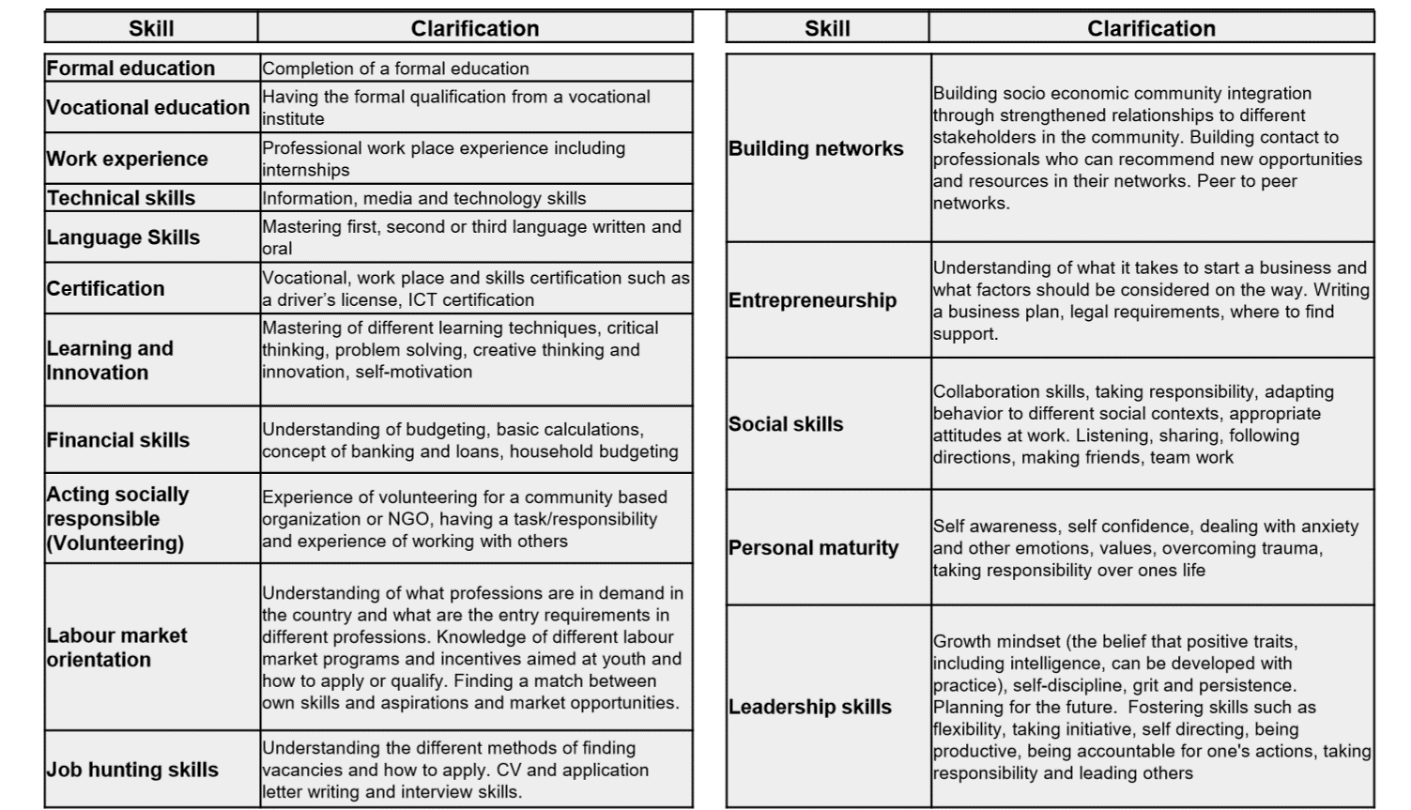

## Annex 3: Summary of workshop results (input to kick-off meeting)

**NEEDS ASSESSMENT WORKSHOP REPORT**

**Result 1: Ranking of employment factors:**

*Fill in table or paste picture of flipchart.*

|  |  |
| --- | --- |
| Position | Employment factor |
| 1 |  |
| 2 |  |
| 3 |  |
| 4 |  |
| 5 |  |
| 6 |  |
| 7 |  |
| 8 |  |
| 9 |  |
| 10 |  |

**Result 2: Impact statement**

*Please insert the impact statement (in written form or a picture of the flipchart).*

**Result 3: Outcome/output statements per employment factor**

*Fill in table or paste picture of flipchart.*

|  |  |
| --- | --- |
| **Employment factor** | **Outcome/output statements** |
| *e.g. Job searching skills* | *e.g.*   * *Young people know how to write an application.* * *Young people know how to prepare for a job interview* |
|  |  |
|  |  |
|  |  |
|  |  |
| *Please add more lines if needed.* |  |

**Information on participants (optional)**

*Please give information on the number of participants, their relation to SOS CV (from Alternative Care, FS, or community/other NGOs), their age range, and their education level.*

## Annex 4: Photographic/media consent form

**PHOTOGRAPHIC / MEDIA CONSENT FORM**

I hereby consent to the collection and use of my personal images by photography or video recording. I acknowledge these may be used on the internal SOS Children’s Villages International Intranet page, as well as in newsletters distributed to SOS Children’s Villages co-workers.

I understand that no personal information, besides my name and country, will be used in any on the SOS Children’s Villages intranet unless express consent is given.

I also understand that my consent can be withdrawn at any time in writing to

Ulla Riedle, SOS Children’s Villages International - Ulla.Riedle@sos-kd.org

I ……………………………………………………………………………………………………

(Name of person giving consent & parent/guardian if under 18 years of age)

consent to the use of photographs or video footage for use internal SOS Children’s Villages International Intranet page, as well as in newsletters distributed to SOS Children’s Villages co-workers.

Consent to the use of photographs or video footage being used to promote future the 2030 Youth Coalition within our organisation.

I further understand that this consent may be withdrawn by me at any time, upon written notice.

I give this consent voluntarily.

………………………………………………….. ………………………………………………..

Signature of person giving consent Signature of parent/guardian < 18

Date …………………………………………