**YOUTHCAN! TRAINING MATERIAL**

**PARTNER PLANNING WORKSHOP**

YouthCan! partnership programmes can offer a wide range of services to youth. In order to jointly plan for the most required responses, and to match needs with possible responses, a thorough analysis is required for collecting information on needs, gaps and stakeholders.

For this purpose, two different workshops should be conducted in parallel: one with young people (step 2), and one with YouthCan! partners (step 4).

The partner planning workshop (kick-off) should take place before starting YouthCan! activities and corresponds to step 4 as shown below. Ideally, it should be done after the youth needs assessment workshop ([link](https://collaboration.sos-kd.org/Workspaces/WS_000169/Shared%20Documents/Tools%20and%20Resources/Programme%20Implementation/Youth%20consultation/YouthCan-Needs-Assessment-Workshop.docx?Web=1)) or in parallel.

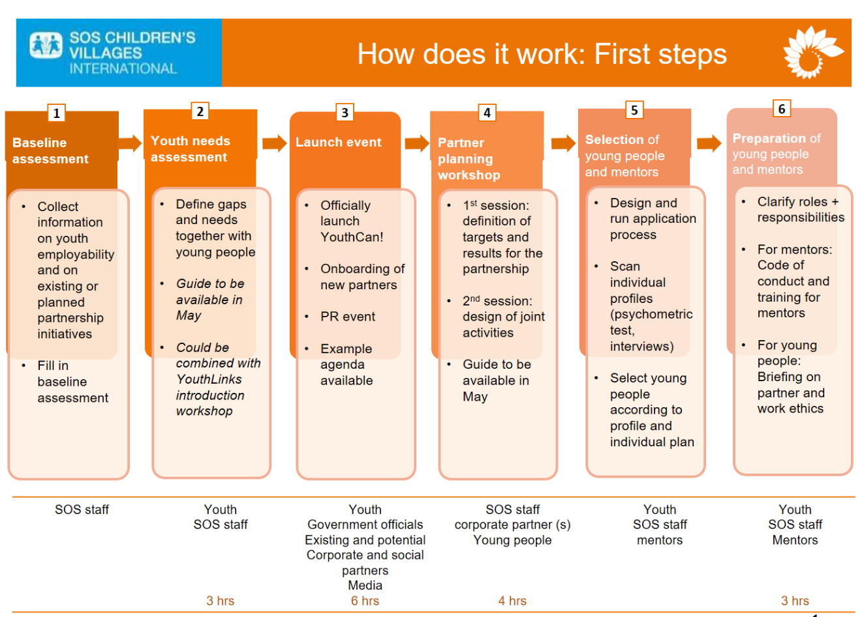

While the objective of the needs assessment workshop is to find out the needs of young people concerning employability the aim of the partner planning workshop (kick-off) is to:

* **Identify gaps**  
  Once the needs of young people in regard to employability are clear ([link to youth needs assessment workshop guide](https://collaboration.sos-kd.org/Workspaces/WS_000169/Shared%20Documents/Tools%20and%20Resources/Programme%20Implementation/Youth%20consultation/YouthCan-Needs-Assessment-Workshop.docx?Web=1)) identify what services / offers are missing at your particular location in order to strengthen employability.
* **Define possible activities for partners addressing identified gaps**Having analyzed existing responses and gaps, determine what can the respective partner(s) contribute and how does each contribution relate to one of the desired results (identified at the youth needs assessment workshop).
* **Design the partnership programme**Knowing gaps and possible activities you can design the partnership programme, describing all activities and their relation to desired results. The planning document ([link](https://collaboration.sos-kd.org/Workspaces/WS_000169/Shared%20Documents/Tools%20and%20Resources/Programme%20Implementation/Partner%20kick-off/MA%20YC!%20Planning%20document.docx?Web=1)) shall help you to gather all relevant information.

Distinction from launch: The focus of the partner planning workshop (kick-off) is on concrete planning, while a launch is an event aiming at getting publicity and reaching as many prospective partners as possible by showing what SOS Children’s Villages does and what YouthCan! is about.

We recommend the following elements to be included in the workshop or done before/after the workshop:

* Presentation of SOS Children’s Villages
  + Background (established when; locations, types of programmes (FSP; FBC), number of children)
  + Describe the target group for SOS CV,
  + Describe the YouthCan! Target group and number of young people
  + Challenges facing young people – needs of young people regards employability
  + How other partners are working on employability programmes
* Presentation of corporate partner(s)
  + Local business activities (What do they do?)
  + Location of businesses in the country
  + Number of employees
  + Recruitment processes / practices
  + Job entry requirements
  + Opportunities for:
    - Mentoring and / or Coaching
    - Internships and / or Job shadowing
    - Workshop/Training sessions (Job Market Orientation, Life skills, Social Skills)
* Visit an SOS programme and/or corporate partner(s) (if time allows)
* Presentation on the YouthCan! project (if needed)
* Matching the Challenges of young people to capabilities of the partner and SOS CV
  + Using the Employability skills and competencies document – identify the areas of need for young people
  + How could the needs be addressed (workshops, mentoring, Internships, job shadowing, workplace exposure)?
  + Determine whether or not there are resources to address the needs within the partner’s business or if the partner would be able to assist by outsourcing some areas – to address the needs of young people
* Formulate a plan of activities for a specific period
  + Draft a schedule of activities, responsible people, dates, number of youth, objectives of activities, required tools, responsibilities of SOS CV, responsibilities of partner.
  + Schedule meetings to plan each activity
  + Objective of the engagement
  + Number of young people, list of young people
  + Number of employees, list of employees
  + Duration of the activity
  + Name of the activity with a description
  + Responsibilities of SOS CV
  + Responsibilities of partner
* Determine Monitoring and Evaluation element per partner

See a possible agenda below.

|  |  |
| --- | --- |
| **Agenda proposal and explanation for the planning session** | |
| **Activity** | **Description** |
| 1. **Results of needs assessment**   approx. 20 min.) | In the needs assessment workshop young people worked on describing a (basic) result chain identifying their needs concerning employability, formulating an impact statement, and brainstorming on output/outcome indicators. The following results are provided by them:   * **What do young people need to be better equipped for their career (needs)?** * **What is the final goal concerning youth employability (impact statement)?** * **What needs to be improved/changes as a precondition in order to get to this final goal (output/outcome statements)?**   Results have been gathered in the ‘Summary of workshop results template’ and ideally should be presented by the young people themselves ([link to needs assessment workshop guide](https://collaboration.sos-kd.org/Workspaces/WS_000169/Shared%20Documents/Tools%20and%20Resources/Programme%20Implementation/Youth%20consultation/YouthCan-Needs-Assessment-Workshop.docx?Web=1)). |
| 1. **Relate possible responses to identified needs**   approx. 40 min.) | Reviewing the input by the young people the following questions should be discussed:   1. **After reviewing the inputs from youth, is there anything your company can offer in order to overcome one of the most frequently named challenges or gaps?** 2. **Beyond the input from young people, what else could you contribute to improve the employability situation? Do you perceive any additional gaps that need to be addressed?**   Depending on the number of participants, you either discuss these questions in the plenary, or split up in smaller groups. If you prefer splitting up in groups, keep about 15 minutes for a discussion in the plenary to get to a final agreement concerning identified gaps.  Then move to the next point. |
| 1. **Define possible activities for partner(s) to address gaps**   approx. 40 min.) | Discuss the following questions:   1. **What concrete activities do you offer to address identified gaps.** 2. **Why and how do you believe this can contribute towards achieving one of the different results (outcome/output statements) the youth have formulated previously?**   Either split up in pairs or in two groups making sure that having one representative of each partner in each group.  Distribute identified gaps to the groups and brainstorm about possible activities to address these gaps. Also, formulate how these activities relate to one of the outcome/output statements formulated by the young people during the [youth needs assessment workshop](https://collaboration.sos-kd.org/Workspaces/WS_000169/Shared%20Documents/Tools%20and%20Resources/Programme%20Implementation/Youth%20consultation/YouthCan-Needs-Assessment-Workshop.docx?Web=1) (result 3). You can also reformulate/change/add the given outcome/output statements if needed as long as it fits into the result chain developed by the young people during the [youth needs assessment workshop](https://collaboration.sos-kd.org/Workspaces/WS_000169/Shared%20Documents/Tools%20and%20Resources/Programme%20Implementation/Youth%20consultation/YouthCan-Needs-Assessment-Workshop.docx?Web=1).  In the plenary, each pair or group present their ideas of possible activities on flipcharts, linking it with the underlying gap and a specific outcome/output indicator.   |  |  |  | | --- | --- | --- | | Gap (unaddressed need) | | | | **Possible activity 1** | **Possible activity 2** | **Possible activity 3** | | Related outcome/output indicator | Related outcome/output indicator | Related outcome/output indicator |   After all proposed activities are clear to all participants, every participant gets three sticky dots.   * Young people are asked to rate the three most important & interesting activities from their perspective; * SOS staff is asked to rate the three most important & useful activities from their perspective; * Partner staff is asked to rate the three most important & feasible activities from their perspective;   by simply stick their sticky dots next to the specific activities.  While the participants take a break, the facilitator compiles those activities that got the most sticky dots.  After the break move on to point 4. |

|  |  |
| --- | --- |
| 1. **Design the partnership programme**   approx. 40 min.) | After looking at the compilation of activities made by the facilitator, choose the top 3-5 and start filling the [planning template](https://collaboration.sos-kd.org/Workspaces/WS_000169/Shared%20Documents/Tools%20and%20Resources/Programme%20Implementation/Partner%20kick-off/MA%20YC!%20Planning%20document.docx?Web=1):   * All planned activities next to their contribution to desired results * Overall goal (impact; presented by young people) * Mention briefly identified gaps   Also, define next steps, e.g.   * Are there any internal checks the partner(s) will need to do inside the company? * Aare there any check SOS CV needs to do? * When is a final draft of the plan ready? * Who needs to approve it? Etc. |

If you have any further question please do not hesitate to contact [Sophie Crockett-Chaves](mailto:Sophie.Crockett-Chaves@sos-kd.org) (M&E Advisor) or [Hugh Eggar](mailto:Hugh.Eggar@sos-kd.org) (YC! Project Manager).