Menu of Activities: GoTeach

1. Mentoring

Mentor a student, supporting them to develop the skills and attitudes needed to progress into employment, training or further education

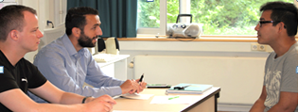

Run a CV & Interview Skills workshop for young people – helping them to create an impactful CV and learn how to prepare for an interview

2. CV & Interview

Session

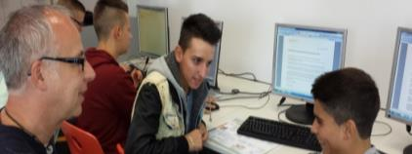

3. Career Session

Help students develop their career plan and provide an insight into career opportunities and apprenticeships.

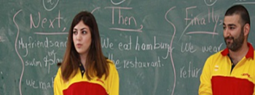

4. Classroom

Session

Inspire students in the classroom by delivering a guest teacher lesson. As a role model, you will help the students think differently about the world of work and careers in the logistics industry.



5. Employability

Workshop

Run a workshop that supports young people to develop employability skills and helps attract more young people into Logistics.

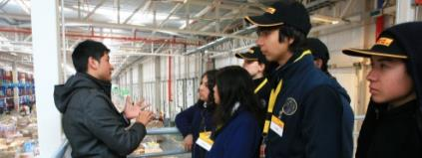

6. Site Visit

Provide an immersive and interactive site visit at a local site or office. This includes a site tour, career Q&A with DPDHL colleagues, and logistics-themed problem solving and teamwork activities.

7. Career Fair

Allow young people to obtain information about the professional work environment and provide an insight into career opportunities and apprenticeships. Stands are set up and each department the variety of professional opportunities, as well as their own work experience.

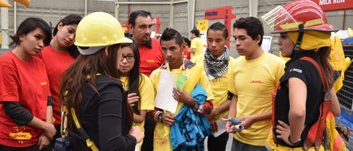

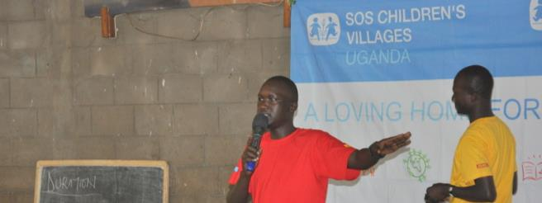

8. Entrepreneurship

Training

Train young people to start their own business covering areas like business plan writing, promoting their business, looking for funds etc.

10. Entrepreneur-

ship Training

Train young people to start their own business covering areas like business plan writing, promoting their business, looking for funds etc.

9. Career Fair

Allow young people to obtain information about the professional work environment and provide an insight into career opportunities and apprenticeships. Stands are set up and each department the variety of professional opportunities, as well as their own work experience.



9. Internship

Provide a students with an opportunity to experience the working week in a real business environment, doing a job that benefits the employer and put into practice what employability skills they have already developed.



10. Job Shadowing

Young people accompany employees over a week or less to learn what it means to work in a certain area



Menu of Activities: UK Foundation

1. Mentoring

Using your skills and experience to support and mentor a student, young person or newly qualified teacher

2. Residential Mentor

Take part in outdoor experiential learning with students, helping increase their resilience, confidence, emotional wellbeing and relationship skills

3. Teacher Coach

Coach and support a newly qualified teacher to be the best they can be in the classroom.

4. Site Visits

Hosting students for an interactive Site visit at a local DHL site or office. This includes a site tour, career Q& A with DHL colleagues and logistics- themed problem solving and team activities

5. Classroom Activities

A short assembly / lesson by a DHL colleague in a school. The activities are designed to inspire pupils, showcase DHL and introduce students to a career in the logistics industry

7. Outdoor Learning

Colleagues support young people to develop their skills through an unforgettable outdoor educational residential experience with a leading UK youth charity

9. Work Experience and Employability through Sports

An opportunity to engage with unemployed young people through football, dance, fitness and help them recognize the transferable skills these sports offer. All of the young people are on a structured employability programme designed to build their skills, confidence and to secure employment

11. Meet the young people you help

Meeting the young people you help

10. Trucks & Child Safety (TACS)

An interview session educating children between 7 -11years about road safety and the dangers of large vehicles in their local communities, delivered in primary schools across the UK

6. Employability skills Workshops

A practical and engaging workshop designed to help students develop employability skills. It is an opportunity for colleagues to showcase their own transferable skills and role within logistics, delivered in a classroom

8. CV & Interview Skills Workshop

A hands on workshop designed to assist students with CV writing and interview techniques delivered in the classroom

12. School Visit Schools

Visit a school to learn more life in a school. This is an opportunity to learn more about how the GoTeach charity Partners support pupils and teachers in a school

13. Meet the GoTeach UK Ambassadors

Meeting the GoTeach Ambassadors

14. Local Advisory Board Member

Work with a school and local businesses to help the growth and development of engagement opportunities provided to students

Menu of Activities: Refugee Programme

Some activities listed under GoTeach are also applicable to the Refugee programme

1. Language Buddies

Language buddies help pupils with homework as they adjust to a new language.

2. Reading Buddies

Reading buddies promote language skills for children by reading aloud. Literature tailored to the target group is interactively prepared within the framework of reading aloud in primary schools. Special reading boxes are offered to children with a migration background

3. Intercultural communications and presentation skills

Multiple workshop sessions including speaking confidently (focused on women); Effective communication and presentation and intercultural competences

4. Digital Classrooms

DHL employees assist with enabling digital engagements between teacher and students / young people. Offering assistance to enable continued learning